From: http://www.npr.org/templates/story/story.php?storyId=124494788
The Audio: https://ondemand.npr.org/anon.npr-mp3/npr/atc/2010/03/20100318_atc_14.mp3?orgId=1&topicId=1016&d=443&p=2&story=124494788&t=progseg&e=124821937&seg=14&siteplayer=true&dl=1

Is The Bible More Violent Than The Quran?
Listen·7:237:23 Apparently this is a text companion for what was fundamentally a 7 min 23 second National Public Radio audio

March 18, 20103:20 AM ET
Heard on All Things Considered
BARBARA BRADLEY HAGERTY
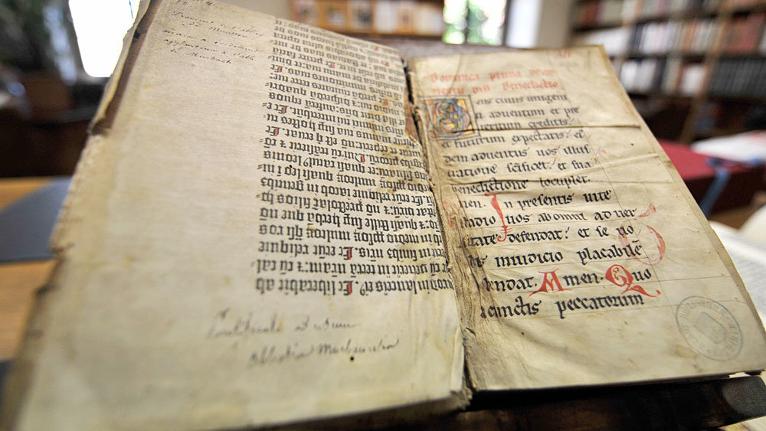
Pages of the Gutenberg Bible in Colmar, France. Religious historian Philip Jenkins says scriptures from the Bible are more violent than those from the Quran.
Johanna Leguerre/AFP/Getty Images
As the hijackers boarded the airplanes on Sept. 11, 2001, they had a lot on their minds. And if they were following instructions, one of those things was the Quran.
In preparation for the suicide attack, their handlers had told them to meditate on two chapters of the Quran in which God tells Muslims to "cast terror into the hearts of unbelievers."
"Slay the idolaters wherever ye find them, arrest them, besiege them, and lie in ambush everywhere for them," Allah instructs the Prophet Muhammad (Quran, 9:5). He continues: "Prophet! Make war on the unbelievers and the hypocrites! ... Hell shall be their home, an evil fate."
When Osama bin Laden declared war on the West in 1996, he cited the Quran's command to "strike off" the heads of unbelievers. More recently, U.S. Army Maj. Nidal Hasan lectured his colleagues about jihad, or "holy war," and the Quran's exhortation to fight unbelievers and bring them low. Hasan is accused of killing 13 people at Fort Hood, Texas, last year.
Given this violent legacy, religion historian Philip Jenkins decided to compare the brutality quotient of the Quran and the Bible.
Defense Vs. Total Annihilation
"Much to my surprise, the Islamic scriptures in the Quran were actually far less bloody and less violent than those in the Bible," Jenkins says.
Jenkins is a …….

Violence in the Quran, he and others say, is largely a defense against attack.
Then we turn to the Bible, and we actually find something that is for many people a real surprise. There is a specific kind of warfare laid down in the Bible which we can only call genocide."
It is called herem, and it means total annihilation. Consider the Book of 1 Samuel, when God instructs King Saul to attack the Amalekites: "And utterly destroy all that they have, and do not spare them," God says through the prophet Samuel. "But kill both man and woman, infant and nursing child, ox and sheep, camel and donkey."
When Saul failed to do that, God took away his kingdom.
"In other words," Jenkins says, "Saul has committed a dreadful sin by failing to complete genocide. And that passage echoes through Christian history. It is often used, for example, in American stories of the confrontation with Indians — not just is it legitimate to kill Indians, but you are violating God's law if you do not."
Jenkins notes that the history of Christianity is strewn with herem. During the Crusades in the Middle Ages, the Catholic popes declared the Muslims Amalekites. In the great religious wars in the 16th, 17th and 19th centuries, Protestants and Catholics each believed the other side were the Amalekites and should be utterly destroyed.
'Holy Amnesia'
But Jenkins says, even though the Bible is violent, Christianity and Judaism today are not for the most part.
[“Good Times”, rather than the passage of years, would be my guess for what causes “Holy Amnesia”. –FNC]
"What happens in all religions as they grow and mature and expand, they go through a process of forgetting of the original violence, and I call this a process of holy amnesia," Jenkins says.
They make the violence symbolic: Wiping out the enemy becomes wiping out one's own sins. Jenkins says that until recently, Islam had the same sort of holy amnesia, and many Muslims interpreted jihad, for example, as an internal struggle, not physical warfare.
Andrew Bostom calls this analysis "preposterous." Bostom, editor of The Legacy of Jihad, says there's a major difference between the Bible, which describes the destruction of an enemy at a point in time, and the Quran, which urges an ongoing struggle to defeat unbelievers.
"It's an aggressive doctrine," he says. "The idea is to impose Islamic law on the globe."
Take suicide attacks, he says — a tactic that Muslim radicals have used to great effect in the U.S., Iraq, Afghanistan and the Middle East. It's true that suicide from depression is forbidden in Islam — but Bostom says the Quran and the Hadith, or the sayings of Muhammad, do allow self-destruction for religious reasons.
"The notion of jihad martyrdom is extolled in the Quran, Quran verse 9:1-11. And then in the Hadith, it's even more explicit. This is the highest form of jihad — to kill and to be killed in acts of jihad."
'Out Of Context'
That may be the popular notion of jihad, says Waleed El-Ansary, but it's the wrong one. El-Ansary, who teaches Islamic studies at the University of South Carolina, says the Quran explicitly condemns religious aggression and the killing of civilians. And it makes the distinction between jihad — legal warfare with the proper rules of engagement — and irjaf, or terrorism.
"All of those types of incidences — [Sept. 11], Maj. Nidal Hasan and so forth — those are all examples of irjaf, not jihad," he says. According to the Quran, he says, those who practice irjaf "are going to hell."
So what's going on here? After all, we all have images of Muslim radicals flying planes into buildings, shooting up soldiers at Fort Hood, trying to detonate a bomb on an airplane on Christmas Day. How to reconcile a peaceful Quran with these violent acts?
El-Ansary says that in the past 30 years, there's been a perfect storm that has created a violent strain of Islam. The first is political: frustration at Western intervention in the Muslim world. The second is intellectual: the rise of Wahhabi Islam, a more fundamentalist interpretation of Islam subscribed to by Osama bin Laden. El-Ansary says fundamentalists have distorted Islam for political purposes.
"Basically what they do is they take verses out of context and then use that to justify these egregious actions," he says.
El-Ansary says we are seeing more religious violence from Muslims now because the Islamic world is far more religious than is the West. Still, Jenkins says Judeo-Christian cultures shouldn't be smug. The Bible has plenty of violence.
"The scriptures are still there, dormant, but not dead," he says, "and they can be resurrected at any time. Witness the white supremacists who cite the murderous Phineas when calling for racial purity, or an anti-abortion activist when shooting a doctor who performs abortions.
In the end, the scholars can agree on one thing: The DNA of early Judaism, Christianity and Islam code for a lot of violence. Whether they can evolve out of it is another thing altogether.
[Here is the end of the 7 minute 22 second audio radio broadcast. –FNC]

Excerpt: 'Jesus Wars'
PHILIP JENKINS
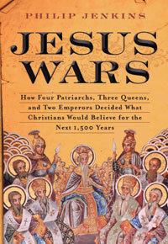
Introduction
Who Do You Say That I Am?
Jesus once asked his disciples, "Who do people say that I am?" They answered that all sorts of stories were circulating — that he was a prophet, perhaps Elijah or John the Baptist come back to earth. "But," he asked, "Who do you say that I am?" Over the past two thousand years, Christians have formulated many different answers to this question. Yes, most believe Jesus was a human being, but at the same time he was also God, one of the three persons of the Trinity. He was both God and man.

JESUS WARS: HOW FOUR PATRIARCHS, THREE QUEENS, AND TWO EMPERORS DECIDED WHAT CHRISTIANS WOULD BELIEVE FOR THE NEXT 1,500 YEARS
BY PHILIP JENKINS
HARDCOVER, 352 PAGES
HARPERONE
LIST PRICE: $26.99

But when we have said that, we have raised more questions than we have answered, as the basic belief in Jesus Christ demands combining two utterly different categories of being. Such a transgression of boundaries puzzles and shocks believers of other faiths, especially strict monotheists such as Muslims and Jews. But even those Christians who accept the basic concept probably could not explain it with anything like the precision demanded by early church councils. By those rigorous standards, virtually all modern nonspecialists (including many clergy) would soon lapse into grave heresy. . . .
So was Jesus a Man-bearing God, or a God-bearing man? Between those extreme poles lay any number of other answers, which competed furiously through the first Christian centuries. By 400, most Christians agreed that Jesus Christ was in some sense divine, and that he had both a human nature (Greek, physis) and a divine nature. But that belief allowed for a wide variety of interpretations, and if events had developed differently — if great councils had decided other than they actually did — any one of these various approaches might have established itself as orthodoxy. In the context of the time, cultural and political pressures were pushing strongly toward the idea of Christ-as-God, so that only with real difficulty could the memory of the human Jesus be maintained. Historically, it is very remarkable that mainstream orthodoxy came out so strongly in favor of asserting Christ's full humanity.
And yet it did just that. When most modern churches explain their understanding of Christ's identity — their Christology — they turn to a common body of ready-made interpretations, an ancient collection of texts laid down in the fifth century. At a great council held in 451 at Chalcedon (near modern Istanbul), the church formulated the statement that eventually became the official theology of the Roman Empire. This acknowledges Christ in two natures, which joined together in one person. Two natures existed, "without confusion, without change, without division, without separation; the distinction of natures being in no way annulled by the union, but rather the characteristics of each nature being preserved and coming together to form one person."
We cannot speak of Christ without declaring his full human nature, which was not even slightly diluted or abolished by the presence of divinity. That Chalcedonian definition today stands as the official formula for the vast majority of Christians, whether they are Protestant, Catholic, or Orthodox — although how many of those believers could explain the definition clearly is open to debate. But as we are told, Chalcedon settled any controversy about the identity of Christ, so that henceforward any troublesome passages in the Bible or early tradition had to be read in the spirit of those powerful words. For over 1,500 years now, Chalcedon has provided the answer to Jesus' great question.
But Chalcedon was not the only possible solution, nor was it an obvious or, perhaps, a logical one. Only the political victory of Chalcedon's supporters allowed that council's ideas to become the inevitable lens through which later generations interpret the Christian message. It remains quite possible to read the New Testament and find very different Christologies, which by definition arose from churches very close to Jesus' time, and to his thought world. In particular, we easily find passages that suggest that the man
Jesus achieved Godhood at a specific moment during his life, or indeed after his earthly death.
In political terms, the most important critics of Chalcedon were those who stressed Christ's one divine nature, and from the Greek words for "one nature," we call them Monophysites. Not only were Monophysites numerous and influential, but they dominated much of the Christian world and the Roman Empire long after Chalcedon had done its work, and they were only defeated after decades of bloody struggle. Centuries after Chalcedon, Monophysites continued to prevail in the most ancient regions of Christianity, such as Syria, Palestine, and Egypt. The heirs of the very oldest churches, the ones with the most direct and authentic ties to the apostolic age, found their distinctive interpretation of Christ ruled as heretical. Pedigree counted for little in these struggles.
Each side persecuted its rivals when it had the opportunity to do so, and tens of thousands — at least — perished. Christ's nature was a cause for which people were prepared to kill and to die, to persecute or to suffer martyrdom. Modern Christians rarely feel much sympathy for either side in such bygone religious wars. Did the issues at stake really matter enough to justify bloodshed? Yet obviously, people at the time had no such qualms and cared passionately about how believers were supposed to understand the Christ they worshipped. Failing to understand Christ's natures properly made nonsense of everything Christians treasured: the content of salvation and redemption, the character of liturgy and Eucharist, the figure of the Virgin Mary. Each side had its absolute truth, faith in which was essential to salvation.
Horror stories about Christian violence abound in other eras, with the Crusades and Inquisition as prime exhibits; but the intra- Christian violence of the fifth- and sixth-century debates was on a far larger and more systematic scale than anything produced by the Inquisition and occurred at a much earlier stage of church history. When Edward Gibbon wrote his classic account of the Decline and Fall of the Roman Empire, he reported countless examples of Christian violence and fanaticism. This is his account of the immediate aftermath of Chalcedon:
Jerusalem was occupied by an army of [Monophysite] monks; in the name of the one incarnate Nature, they pillaged, they burnt, they murdered; the sepulchre of Christ was defiled with blood. . . . On the third day before the festival of Easter, the [Alexandrian] patriarch was besieged in the cathedral, and murdered in the baptistery. The remains of his mangled corpse were delivered to the flames, and his ashes to the wind; and the deed was inspired by the vision of a pretended angel. . . . This deadly superstition was inflamed, on either side, by the principle and the practice of retaliation: in the pursuit of a metaphysical quarrel, many thousands were slain.
Chalcedonians behaved at least as badly in their campaigns to enforce their particular orthodoxy. In the eastern city of Amida, a Chalcedonian bishop dragooned dissidents, to the point of burning them alive. His most diabolical scheme involving taking lepers, "hands festering and dripping with blood and pus," and billeting them on the Monophysite faithful until they saw reason.
Even the Eucharist became a vital component of religious terror. Throughout the long religious wars, people were regularly (and frequently) reading others out of the church, declaring formal anathemas, and the sign for this was admitting or not admitting people to communion. In extreme episodes, communion was enforced by physical violence, so that the Eucharist, which is based upon ideas of self-giving and self-sacrifice, became an instrument of oppression. A sixth-century historian records how the forces of Constantinople's Chalcedonian patriarch struck at Monophysite religious houses in the capital. Furnished with supplies of consecrated bread, the patriarch's clergy were armed and dangerous. They "dragged and pulled [the nuns] by main force to make them receive the communion at their hands. And they all fled like birds before the hawk, and cowered down in corners, wailing and saying, 'We cannot communicate with the synod of Chalcedon, which divides Christ our God into two Natures after the union, and teaches a Quaternity instead of the Holy Trinity.'" But their protests were useless. "They were dragged up to communicate; and when they held their hands above their heads, in spite of their screams their hands were seized, and they were dragged along, uttering shrieks of lamentation, and sobs, and loud cries, and struggling to escape. And so the sacrament was thrust by force into the mouths of some, in spite of their screams, while others threw themselves on their faces upon the ground, and cursed every one who required them to communicate by force." They might take the Eucharist kicking and screaming — literally — but once they had eaten, they were officially in communion with Chalcedon and with the church that preached that doctrine.
Reprinted from Jesus Wars: How Four Patriarchs, Three Queens, and Two Emperors Decided What Christians Would Believe for the Next 1,500 Years by Philip Jenkins. Copyright 2010. With permission of the publisher, HarperOne.

